Student Performance Prediction System

Project Id: AIML-5

Name : Anushka Tiwari (Team Leader)
Class Roll Number: 36
University Roll Number : 2028657
Section and Group: Q(G1)

Name : Sneha Rawat
Class Roll Number:17
University Roll Number : 2028500
Section and Group: Q(G1)

- Problem Description 3
- Architecture 4
- Models model 5
- Evaluation metrics used 6
- Preliminary Results and Visualizations 7
- References 8

1. Problem Description
The Credit Card Fraud Detection System is a Machine Learning based application developed to automatically detect fraudulent credit card transactions. The system analyzes transaction data and predicts whether a transaction is legitimate or fraudulent.
In this project:
- 0 → Legitimate Transaction
- 1 → Fraudulent Transaction
The main objective of the project is to reduce financial fraud by identifying suspicious transactions accurately and efficiently. The system uses Machine Learning techniques such as data preprocessing, feature scaling, classification algorithms, and performance evaluation metrics to improve fraud detection.
The project also focuses on handling imbalanced datasets because fraudulent transactions are significantly fewer compared to legitimate transactions.
Objectives of the Project
- Detect fraudulent transactions accurately
- Minimize false negative predictions
- Improve fraud detection efficiency
- Compare Machine Learning algorithms
- Build a scalable fraud detection system

2. Architecture
The overall workflow of the Credit Card Fraud Detection System is shown below.

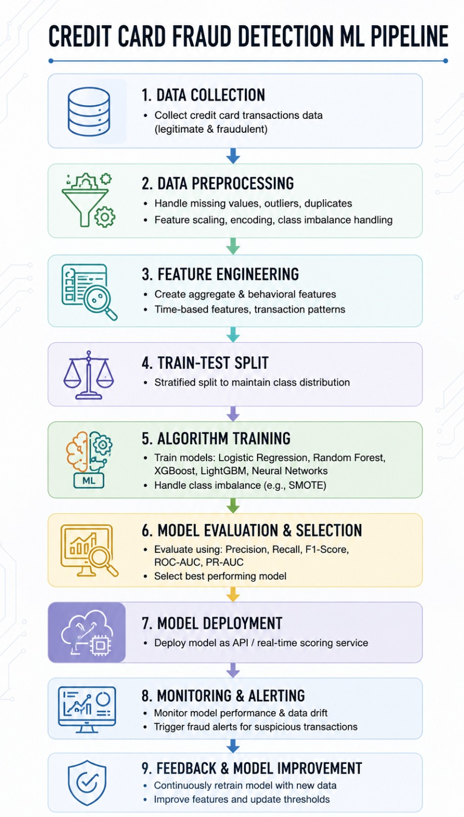

System Workflow
Transaction Dataset
↓
Data Preprocessing
↓
Handling Missing Values
↓
Encoding Categorical Data
↓
Outlier Handling using IQR
↓
Feature Scaling
↓
Train-Test Split
↓
Machine Learning Models
↓
Prediction (0 or 1)
↓
Performance Evaluation

Preprocessing Techniques Used
1. Handling Missing Values
Missing values were checked and handled to improve dataset quality.
2. Encoding
Categorical columns were converted into numerical form for machine learning compatibility.
3. Outlier Handling using IQR Method
The Interquartile Range (IQR) method was used to identify and handle outliers in numerical columns.
4. Feature Scaling
StandardScaler was applied to normalize the feature values. Scaling is important for algorithms such as Logistic Regression and KNN.
5. Train-Test Split
The dataset was divided into training and testing data using stratified sampling to maintain class balance.

3. Models Used (Applied / Planned)
3.1 Logistic Regression
Logistic Regression is a supervised machine learning classification algorithm used for binary classification problems. It predicts whether a transaction is fraudulent or legitimate.
In this project:
- 0 → Legitimate Transaction
- 1 → Fraudulent Transaction
The model estimates the probability of a transaction belonging to a particular class and classifies it accordingly.
Advantages
- Simple and fast
- Effective for binary classification
- Easy to interpret
- Provides good baseline performance
Logistic Regression Implementation
from sklearn.model_selection import train_test_split
from sklearn.preprocessing import StandardScaler
from sklearn.linear_model import LogisticRegression
from sklearn.metrics import classification_report
X = df.drop("Class", axis=1)
y = df["Class"]
X_train, X_test, y_train, y_test = train_test_split(
X, y,
test_size=0.2,
random_state=42,
stratify=y
)
scaler = StandardScaler()
X_train = scaler.fit_transform(X_train)
X_test = scaler.transform(X_test)
model = LogisticRegression(
class_weight='balanced',
max_iter=1000
)
model.fit(X_train, y_train)
y_pred = model.predict(X_test)
print(classification_report(y_test, y_pred))

3.2 K-Nearest Neighbors (KNN)
K-Nearest Neighbors (KNN) is a supervised machine learning algorithm that classifies data based on the nearest neighboring data points.
The algorithm identifies the closest transactions and predicts the class based on majority voting.
Advantages
- Simple to understand
- Effective for classification problems
- Works well with scaled data
Limitations
- Computationally expensive for large datasets
- Sensitive to feature scaling
KNN Implementation
from sklearn.neighbors import KNeighborsClassifier
knn = KNeighborsClassifier(n_neighbors=5)
knn.fit(X_train, y_train)
y_pred_knn = knn.predict(X_test)
print(classification_report(y_test, y_pred_knn))

4. Evaluation Metrics Used
Since fraud detection datasets are imbalanced, multiple evaluation metrics were used instead of relying only on accuracy.

4.1 Accuracy
Accuracy measures the percentage of correctly classified transactions.
Accuracy = (TP + TN) / Total Predictions

4.2 Precision
Precision measures how many predicted fraud transactions were actually fraud.
Precision = TP / (TP + FP)

4.3 Recall
Recall measures how many actual fraud cases were correctly identified.
Recall = TP / (TP + FN)
Recall is one of the most important metrics in fraud detection because missing fraudulent transactions can result in financial loss.

4.4 F1-Score
F1-score provides a balance between Precision and Recall.
F1 Score = 2 × (Precision × Recall) / (Precision + Recall)

4.5 Confusion Matrix
A confusion matrix helps visualize model performance.
Predicted
0 1
Actual 0 TN FP
Actual 1 FN TP
Where:
- TN → True Negative
- FP → False Positive
- FN → False Negative
- TP → True Positive

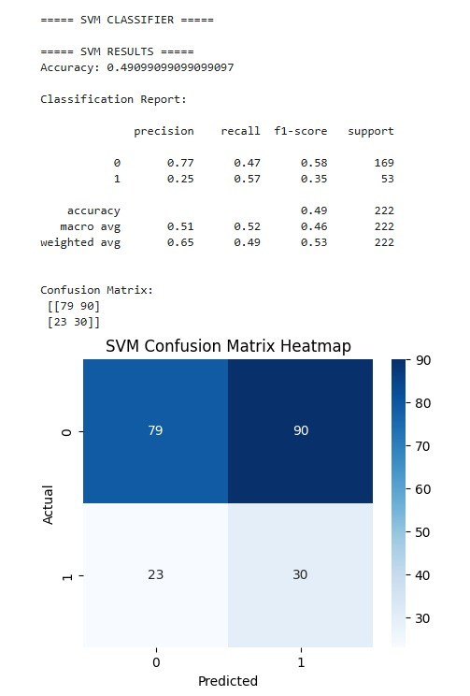

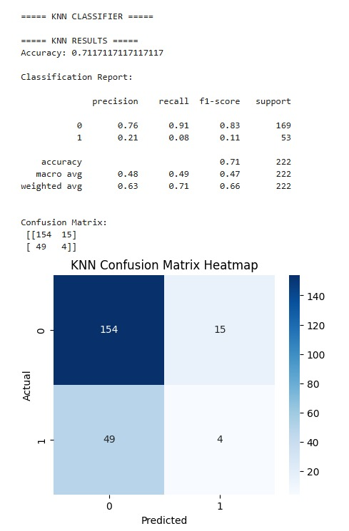

5. Preliminary Results and Visualizations
5.1 Dataset Analysis
The dataset contained a large number of legitimate transactions and a smaller number of fraudulent transactions, resulting in class imbalance.

5.2 Heatmap Visualization
A heatmap was generated to analyze feature correlation and relationships between variables.
Fig.1 Heatmap showing feature correlation.

5.3 Outlier Analysis
Outliers were detected using the IQR method and handled to improve model performance and reduce noise in the dataset.

5.4 Logistic Regression Results
The Logistic Regression model was successfully trained and evaluated using:
- Confusion Matrix
- Classification Report
- Accuracy Score
The model showed effective fraud detection capability and provided a strong baseline for comparison.

5.5 KNN Results
The KNN model was also applied on the scaled dataset and evaluated using classification metrics.
The model classified transactions based on nearest neighboring data points and achieved good classification performance after scaling.

5.6 Observations
- Feature scaling improved model performance
- Stratified splitting maintained class distribution
- Class balancing improved fraud detection recall
- Logistic Regression performed efficiently as a baseline model
- KNN performed effectively after feature scaling

6. References
Books
- Let Us Python – Yashavant Kanetkar

Online Resources
- GeeksforGeeks
- Scikit-learn Documentation
- Pandas Documentation
- NumPy Documentation
- Stack Overflow

Fig.3

